Korea Institute for International Economic Policy
Jeong Eun LEE
Building C, Sejong National Research Complex,
370 Sicheong-daero, Sejong-si, 30147, South Korea

Invoice number: 26005 St.Gallen, 14 January 2026
Invoice date: 14 Jan 2026 Invoice: NIPO data purchase for academic library purposes
Due date: 13 Feb 2026

Dear Mr Lee

In accordance with our agreement, we hereby issue an invoice for an academic library purchase of the New Industrial Policy Observatory. This subscription is valid from January 2026 to December 2026.

Purchase fee: CHF 1,250.00
Invoice total: CHF 1,250.00

Please transfer this amount in full to the following bank account:

Account Holder: St.Gallen Endowment for Prosperity through Trade
Bank name: St.Galler Kantonalbank
IBAN: CH80 0078 1624 8968 1200 0
BIC: KBSGCH22

Alternatively, you can pay by credit card here.

Your support for the St.Gallen Endowment is highly appreciated.

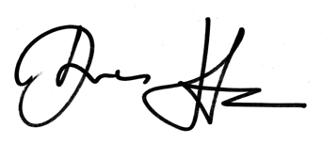
Best regards

